Self-Compassion and Mindfulness:

The following is a link from NAGC, How Self-Compassion Supports Academic Motivation and Emotional Wellness: https://www.kqed.org/mindshift/52854/how-self-compassion-supports-academic-motivation-and-emotional-wellness
There are 2 short video clips (4 and 6 minutes) that contain great reminders for all of us. It also emphasizes that everyone in our school community (including ourselves) needs self-compassion supports. Research shows that our highly driven G.T. and exceptional populations may especially need a bit more support in self-compassion support. This is also a good resource to support everyone during the mid-year assessments taking place in all our school buildings.

We need to reprogram our thinking of wrong answers, roadblocks, or mistakes into NEW LEARNING OPPORTUNITIES!
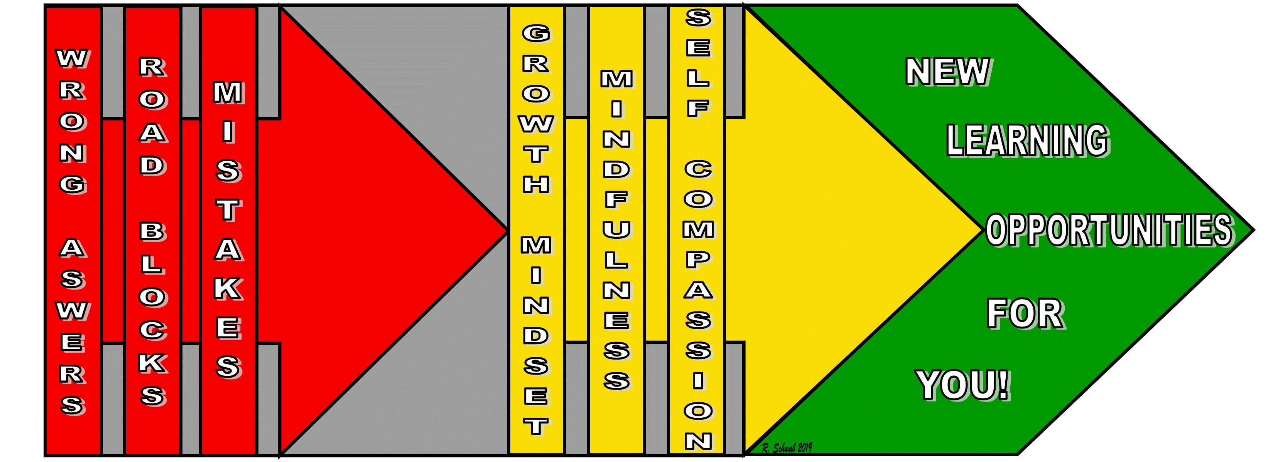
Here is a very short 40 second video clip of some of my former STEAM House 1st and 2nd graders with their thoughts on "What do you do when things don't work the first time?" https://youtu.be/2R5CZnBCwkQ

The following are some resources from Mental Health America to help us cope with test anxiety and may be helpful with the mid-year assessments in our schools:
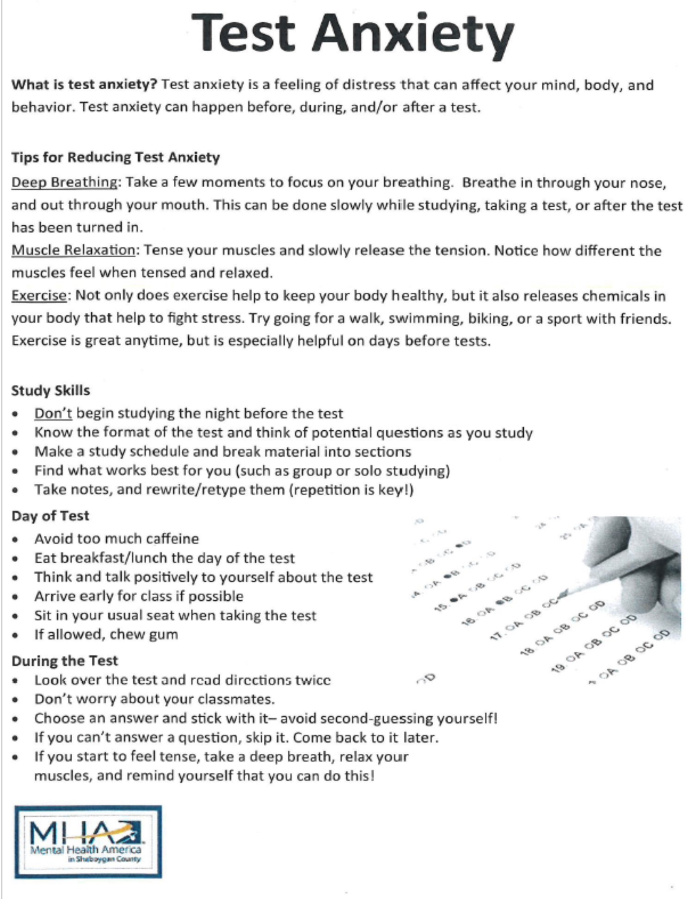

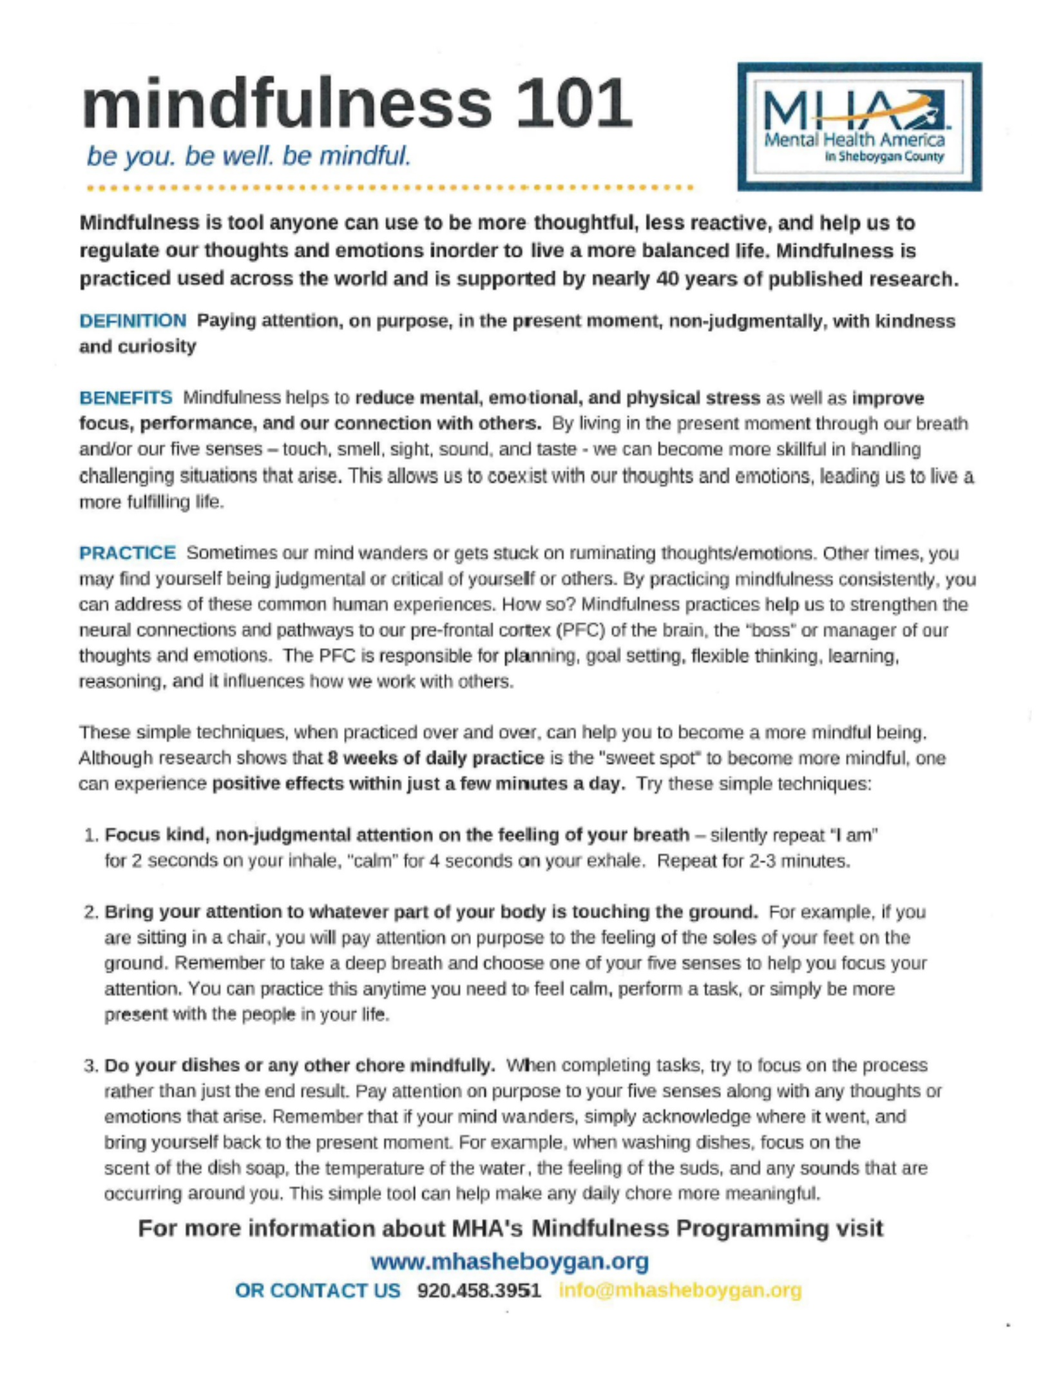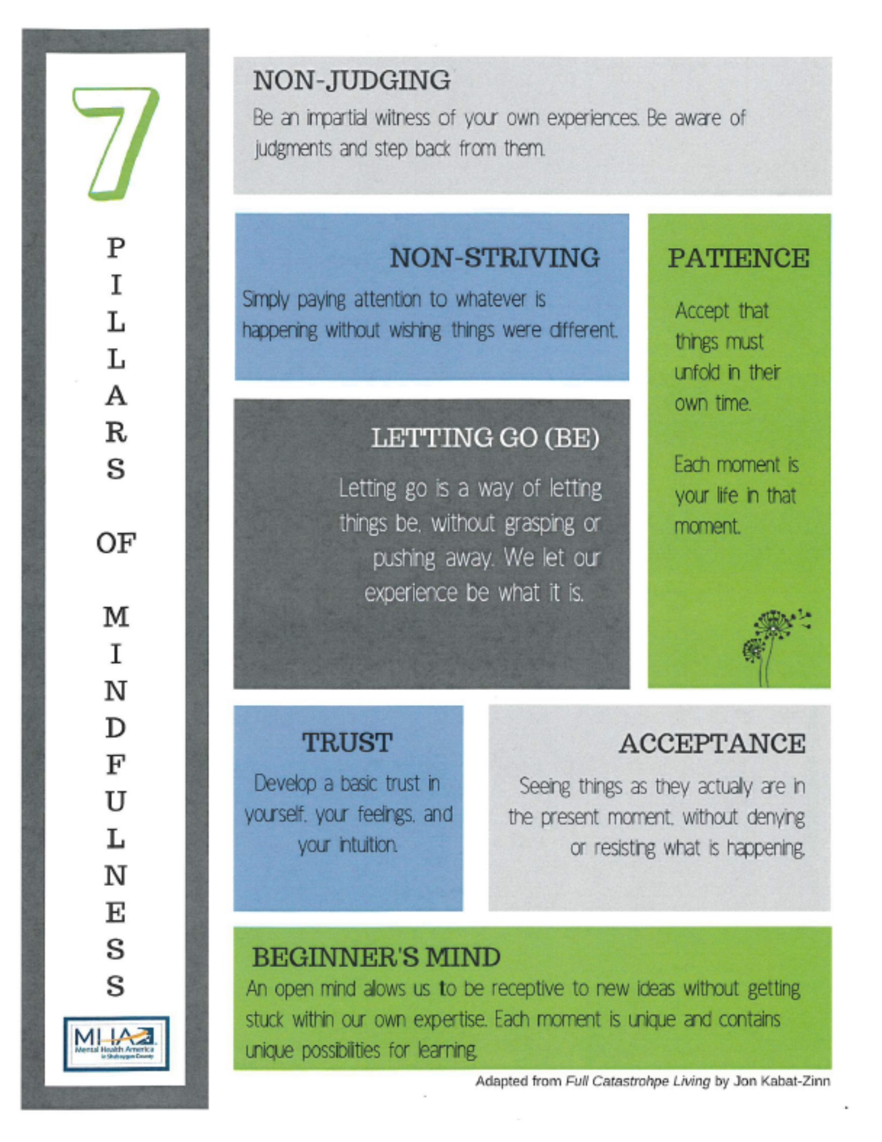
Mindfully,
:-)
Roy

